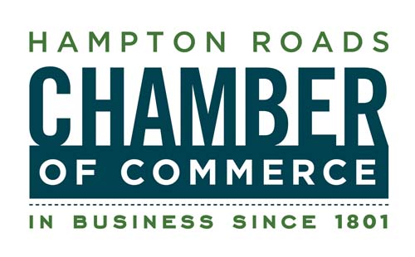

**FOR IMMEDIATE RELEASE**

April 12, 2011

CONTACT:

Lisa Jones

Director, Communications & Marketing

757.664.2531

ljones@hrccva.com

**Senator Mark Warner to meet with Local Young Professionals on April 19 at Harbor Park**

NORFOLK, VA — The Hampton Roads Chamber of Commerce’s **Sync757** young professionals group and the **Urban League of Hampton Roads Young Professionals (ULHRYP)** will host “Happy Hour with a Purpose” with Senator Mark Warner on Tuesday, April 19 at Harbor Park in Norfolk.

Young professionals from around the region will have the opportunity to meet and speak with Senator Warner at Hits at the Park from 5-7pm. Senator Warner will then throw out the first pitch as the Norfolk Tides AAA baseball team takes on the Gwinnett Braves of Lawrenceville, Ga.

The Sync757 program is a young professionals group with the goal of attracting and retaining young talented individuals from the Hampton Roads region. Sync757 is the “voice” for emerging leaders with the mission to connect the “under 40” workforce to our region’s rich resources.  The Chamber’s Sync757 program incorporates four key elements: Mentor, Enrich, Connect, and Engage by providing opportunities to grow personally and professionally through holding monthly events, informing members of relevant issues in the community, and giving members the opportunity to learn from the region’s leaders. Established in 2005, this young professionals program has grown to more than 500 members.

Young professionals in attendance will also receive complimentary “baseball fare” and sodas, have access to a cash bar, and box seats to the Norfolk Tides game.

Tickets for “Happy Hour with a Purpose” are $15 for Sync757 and ULHRYP members and $30 for non-members. To register, call Lindsey Sigafoos at 757-664-2535 or e-mail lsigafoos@hrccva.com.

**About the Hampton Roads Chamber of Commerce (**[**www.HamptonRoadsChamber.com**](http://www.HamptonRoadsChamber.com)**)**

The Hampton Roads Chamber of Commerce is a not-for-profit member-based business organization. The Chamber is a vigorous advocate for the economic success of its nearly 2,000 member businesses, which employ more than 280,000 men and women in southeastern Virginia. The Chamber promotes Hampton Roads’ healthy business climate through economic development, public policy initiatives, services and benefits to members. The Chamber is dedicated to creating economic opportunity and enhancing the quality of life in Hampton Roads.

####