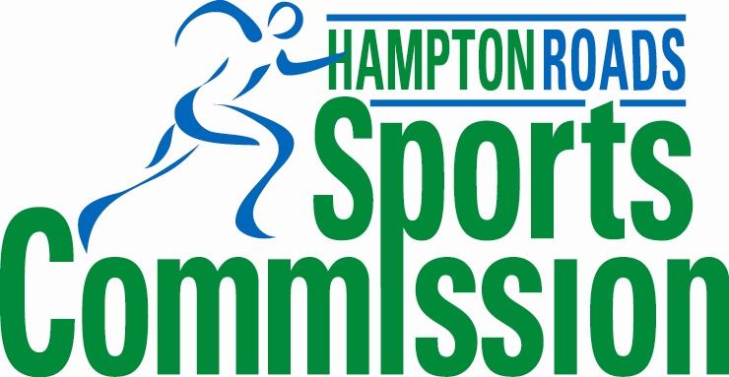


Media Contacts:
Lisa Jones Comm. Mgr., Hampton Roads Chamber of Commerce
ljones@hrccva.com or (757) 664-2531

Jack Ankerson
Executive Director, Hampton Roads Sports Commission
jankerson@hrccva.com or (757) 664-2576

FOR IMMEDIATE RELEASE
October 20, 2010

AAU Junior Olympic Games Delivered Gold for Hampton Roads

Regional Economic Impact of $41 Million from 10-day Event

(Hampton Roads, VA) -- The Amateur Athletic Union (AAU) Junior Olympic Games returned to Hampton Roads this summer from July 29-August 7, 2010. In partnership with the Hampton Roads Sports Commission, an affiliate of the Hampton Roads Chamber of Commerce, five regional cities combined efforts to host the AAU Junior Olympic Games and its 14,733 athletes and their families and 2,329 coaches, venturing here from across the United States and several other countries. The events, 18 in all, took place in venues in Chesapeake, Hampton, Newport News, Norfolk, and Virginia Beach. According to a study conducted by Sportsimpacts, the aggressive estimate of increased regional spending generated by the AAU Junior Olympic Games was $41 million.

The athletes traveling with their families as well as their coaches and/or respective teammates spent money on hotel rooms, rental cars, food, parking, gas, merchandise, entertainment and more. More than 80,000 hotel room nights across the region were generated. Nearly 72% of travelers were visiting the region for the first time. Of the non-locals attending, 72.7% stated their experience at the AAU Junior Olympic Games favorably impacted their perspective/opinion of the region and 55.1% stated they were likely to return to the region as a general tourist within the next two years.

“The AAU Junior Olympic Games is a true regional effort. We are excited about the results of the study that show that this event brought a significant economic impact to the region,” said Jack Ankerson, Hampton Roads Sports Commission executive director. He added, “We are pleased that this year’s AAU Junior Olympic Games brought the second largest number of participants to date. With this momentum, the Hampton Roads Sports Commission is optimistic that when this event returns to the region in 2015, we will have even larger attendance numbers.”

To conduct the economic impact study, Sportsimpacts carried out ‘on-site, event specific’ research through the collection of event questionnaires. Working with a team of data collectors from Old Dominion University’s Sports Management program, the team distributed and collected surveys from event attendees at numerous AAU Junior Olympic Game venues in the region.

Prior to this year, the Hampton Roads Sports Commission produced the AAU Junior Olympic Games in 1998, 2001, and 2006. In 2003, the Sports Commission brought the National Senior Games-the Senior Olympics to the region. In total, the Hampton Roads region has scored an economic impact of more than $177 million from these sports events.

(more)

AAU Junior Olympic Games Delivered Gold for Hampton Roads -- page two

For more information on the 2010 Hampton Roads AAU Junior Olympic Games, visit www.AAUJROGames.org or www.hamptonroadssports.org

About the Hampton Roads Sports Commission
In February of 1999, the Hampton Roads Sports Commission was formed as a public/private partnership among the seven cities of the Hampton Roads Region: Norfolk, Virginia Beach, Portsmouth, Chesapeake, Suffolk, Hampton and Newport News, and the Hampton Roads Chamber of Commerce. The Commission’s primary function is to attract major amateur athletic events to the area and to emphasize regional collaboration. The Hampton Roads Sports Commission is an affiliate of the Hampton Roads Chamber of Commerce. For more information, visit www.hamptonroadssports.org.

About Sportsimpacts
Sportsimpacts conducts economic impact and market research studies for professional and amateur sporting events, teams, leagues, and athletic departments. Founded in 2000, Sportsimpacts has conducted over 60 studies working with clients ranging from CVBs, Sports Commissions, city councils, pro sports teams, and college athletic departments. Sportsimpacts has conducted economic impact studies for the Super Bowl, Ryder Cup, Major League Baseball All-Star Game, Final Fours, and for athletic departments such as Texas, Ohio State, and the University of New Mexico. The Director of Sportsimpacts is Dr. Patrick Rishe, an associate professor of economics at Webster University in St. Louis, Missouri. For more information, visit www.sportsimpacts.net

###

