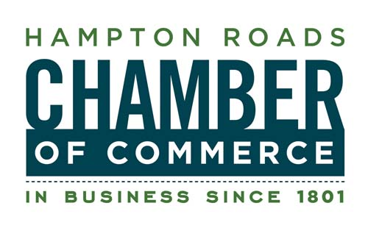
FOR IMMEDIATE RELEASE
May 16, 2012

CONTACT:
Lisa Jones
Communications & Marketing Director
757-664-2531
757-663-9969 (cell)
ljones@hrccva.com

Hampton Roads Chamber of Commerce Honors Local Small Businesses

28th Annual Small Business of the Year Awards to be Held on May 22
During National Small Business Week

HAMPTON ROADS, VA – The Hampton Roads Chamber of Commerce, in partnership with the Small Business Development Center of Hampton Roads (SBDC), will hold its Small Business of the Year Awards luncheon on Tuesday, May 22 at noon at The Founders Inn (5641 Indian River Rd. Virginia Beach). The luncheon coincides with the U.S. Small Business Administration’s “National Small Business Week” which recognizes the contributions of small businesses to the economic well-being of the United States. More than half of Americans either own or work for a small business and also create 60-80% of new jobs in the country.

The Chamber and the SBDC convened a panel of judges to select five businesses, one from each Southside city, to honor. The winning businesses were chosen based on financial performance and business history, staff training and motivation, community involvement, business plan, growth, and customer service and satisfaction. At the luncheon, one of the five city small business winners below will be announced as the Hampton Roads Small Business of the Year.
- Phoenix Group of Virginia, Inc. (Chesapeake)
- TASTE® (Norfolk)
- SimIS (Portsmouth)
- Remedies Salon, Spa & Barber Shop (Suffolk)
- A-Active Termite and Pest Control Company (Virginia Beach)

The “Top 10 to Watch” has also been selected. These businesses are some of the fastest-growing small businesses in the area:
- Evangeline’s Closet
- G For Everyone
- InLineAdz, Inc.
- Joe’s “America’s First Chicken Salad Restaurant”
- Marathon Consulting, LLC
- Trinity Tattoo Co.
- U3C Italian Ice Café
- VOIS, LLC
- We Are Titans
- ZZ Servers

In addition, the Impressions in Print Leadership Award will be presented to Ramon W. Breeden Jr., Founder and Chief Executive Officer of The Breeden Company, for his leadership, impact on workplace culture, community service and involvement, professional achievement, and perseverance.
-more-
Small Business of the Year Awards, 2

A new award this year, the Young Entrepreneur Award (YEA!), will be awarded to Joshua Tawes and Anthony Stile, owners of Accelerated Financial Solutions.

Joel Erb will serve as keynote speaker. Erb’s first company, INM United, was formed after he met with clothing moguls Calvin Klein, Giorgio Armani and Hugo Boss to pitch and present his website designs - at the age of 14! Now at 27, Erb is the president/CEO of two major businesses. His company, Spot Trot works with leading entertainers like Dave Matthews Band and Tim McGraw, and has relationships with Apple, red Light Management, Live Nation Entertainment and others.

Tickets to the Small Business of the Year Awards luncheon are $35 (member) and $50 (prospective member). To register, visit http://events.HamptonRoadsChamber.com. For more information, contact Lindsey Sigafoos at lsigafoos@hrccva.com or 757-664-2535.

Thanks to sponsors: Monarch Bank (Presenting); Inside Business (Media); Impressions in Print (Leadership Award); GovSolutions (Silver); Changes Hair Styling & City Spa;
Issue Track, Inc.; OBBCO Safety & Supply, Inc.; and Young Family & Cosmetic Dentistry (Hall of Fame)

About the Hampton Roads Chamber of Commerce (www.HamptonRoadsChamber.com)
The Hampton Roads Chamber of Commerce is a not-for-profit member-based business organization. The Chamber is a vigorous advocate for the economic success of its nearly 2,000 member businesses, which employ more than 280,000 men and women in southeastern Virginia. The Chamber promotes Hampton Roads’ healthy business climate through economic development, public policy initiatives, services and benefits to members. The Chamber is dedicated to creating economic opportunity and enhancing the quality of life in Hampton Roads.

About the Small Business Development Center of Hampton Roads (www.hrsbdc.org)
The Small Business Development Center of Hampton Roads is a non-profit affiliate of the Hampton Roads Chamber of Commerce and Thomas Nelson Community College in partnership with the U.S. Small Business Administration. It is part of a statewide network of business assistance headed by the Mason Center for Business and Public Policy at George Mason University, and funded primarily by the U.S. Small Business Administration. The SBDC provides management counseling, information, technical assistance, education, and training to small businesses in the region’s 18 cities and counties. It has been serving the greater Hampton Roads region and the Eastern Shore since 1990.

Event photos will be available upon request.

# # #

