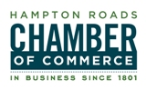
FOR IMMEDIATE RELEASE
March 8, 2012

CONTACTS:
Lisa Jones, Communications & Marketing Director
757-664-2531 (desk), 757-663-9969 (cell)
ljones@hrccva.com

Robyn Showanes, Communications Coordinator
757-664-2533
rshowanes@hrccva.com

Award-Winning Associated Press War Correspondent and Author

Kimberly Dozier to Speak on May 4 at Hampton Roads Chamber Luncheon

NORFOLK, VA — The Hampton Roads Chamber of Commerce will present a luncheon with speaker Kimberly Dozier, an AP correspondent and author of "Breathing the Fire: Fighting to survive and get back to the fight" on Friday, May 4 at noon at the Norfolk Waterside Marriott.

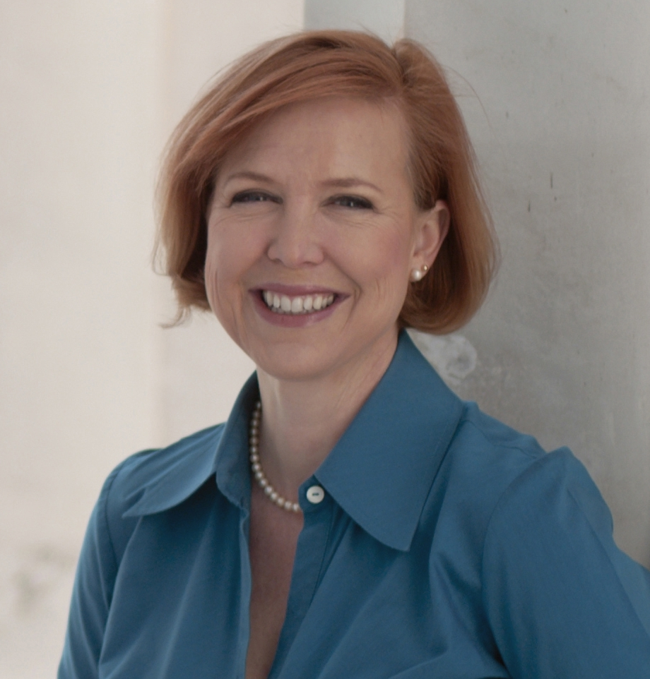
Kimberly Dozier is honored to call herself a WWF, one who was wounded with warriors, and kept alive and put back together by them. A CBS-turned-AP correspondent, she was with troops hit by a car bomb in Iraq in 2006, and turned the attack, rescue and recovery into "Breathing the Fire: Fighting to survive and get back to the fight," about the troops lost that day, and those that fought to keep all of those at the scene alive - and the medical teams that helped put the survivors back together. The book came out in paperback on Veteran's Day 2011, with Dozier’s profits going to charities like Fisher House, Special Operations Warrior Foundation and Injured Marine Semper Fi Fund, in memory of the patrol members Captain James Alex Funkhouser and his translator, and her camera crew, lost that day. Dozier left CBS News in 2010 in order to go back to reporting in war zones. She covers intelligence and special operations for the AP. For more about Kimberly Dozier, visit http://www.kimberlydozier.com/the_author.html

A book signing will take place prior to and immediately following the luncheon. Tickets for the May 4 luncheon are $30. For reservations, visit http://Events.HamptonRoadsChamber.com or call 757-622-2312. A limited number of opportunities are available to host a local Wounded Warrior as a guest at the luncheon. Cost is $500 and includes seats for seven company guests and one Wounded Warrior.

About the Hampton Roads Chamber of Commerce (www.HamptonRoadsChamber.com)
The Hampton Roads Chamber of Commerce is a vigorous advocate for the economic success of its nearly 2,000 member businesses, which employ 280,000 men and women in southeastern Virginia. The Chamber promotes Hampton Roads’ healthy business climate through economic development, public policy initiatives, services and benefits to members. The Chamber is dedicated to creating economic opportunity and enhancing the quality of life in Hampton Roads.

###

